Joystick Gremlin Tutorial for Dual Logitech Extreme 3d Pro Joysticks
This is my Lenovo Legion 5 Pro with dual Logitech Extreme Pro joysticks. They are velcro’d to the wooden chair arms. I have a small sitting/standing desk with a two level platform that holds my laptop on the lower area, and above it a 23” monitor.
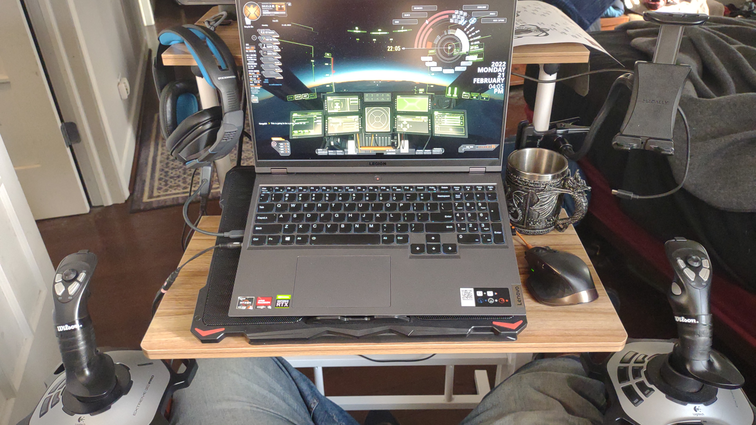
Dual Logitech Extreme joysticks will run you somewhere between $40-$80, depending on sales or getting used ones on eBay. I got my last two on sale from Amazon for $19.95 each. Last I looked they were about $30, but usually they are about $40 for a new device.
They provide everything one would need for a dual joystick setup. I would say that the only thing I miss is perhaps some of the extra hats that I have on my Saitek X-56 on my gaming desktop. But an X-56 HOTAS will cost you about $250-600 or more if you can even find one for sale new or used.
The Logitech Extremes are built to last. While not perfect, with a little tuning they can be really close to perfect for a fraction of the price of other joysticks with higher prices and frankly not as good a build quality (I’m looking at you Thrustmaster 1600!).
Star Citizen is a fantastically fun game that is still in alpha. It does weird stuff with devices sometimes. Rather than trying to start from scratch or lose your mind because Star Citizen keeps getting confused about which joystick is which, especially if you have other controllers you plugin and use. Joystick Gremlin is the way to go to solve this. You can also manage all of the other minute configuration details like sensitivity curves, saturation, and dead zones in Gremlin instead of Star Citizen.
I have to say that one of my favorite features is being able to unplug a device, or plug one in after Star Citizen has launched and have it work without restarting the game. All I have to do is go to Gremlin and reload the profile again and everything just works.

Install Software
- Unplug your joysticks
- Install vJoy
- Install HIDHide
- Install Joystick Gremlin
- Reboot

Configure vJoy
You don't have to do much here. However, if you see strange "wobbling" effects for any axis with the virtual joystick, do the following.
- Open up Device Manager (Windows key - Type Device Manager and select)
- Open "Human Interface Devices"
- Scroll down until you see the vJoy device.
- Rick click and choose "Uninstall device"
- Reinstall vJoy again
- Problem should be resolved

Create a virtual joystick
- Launch “Configure vJoy” from the Windows Start Menu.
- Click the "enable vJoy check box.
- Click the "Add device" button.
- Restart your computer.
- Re-launch Configure vJoy.
- Change the number of buttons to 64 (you need at least 24 for dual Logitechs).
- Make sure that you set the number of hats to at least 2 and make sure "Continuous" is selected.
- Hit apply and restart.
- Plug your joysticks back in.

Configure HIDHide
HIDHide is to cloak your physical joystick devices from Windows and from games. One of the best uses of Joystick Gremlin and HIDHide to to keep your game from getting confused about joystick number order, etc... To do this we hide the physical joysticks from everything except the HIDHide and Joystick Gremlin apps.
- Open HIDHide and make sure the Application tab is selected.
- Hit the "+" button and find the path to the joystick_gremlin.exe and add it to the Applications list. The HidHideClient.exe should be in the applications list by default. Add any other application that you want to see the physical joysticks. I didn't add anything else.
- Open the Devices tab.
- Check the physical devices to hide. In this case, both Logitech joysticks. Leave the Virtual Joystick unchecked.
- Ensure that all three check boxes on the bottom are checked.
- Check "Filter-out disconnected"
- Check "Gaming devices only"
- Check "Enable device hiding"

Configure Joystick Gremlin
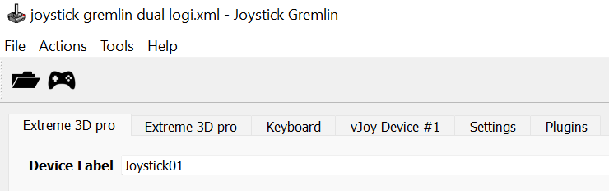
- Open Joystick Gremlin.
It should have two Extreme 3D pro tabs and a vJoy Device #1 tab.

- Now map your axes (plural of axis) from the Logitech joysticks to the Virtual Joystick.
  - Ensure that the right joystick’s Extreme 3D pro tab is selected. You can check this by moving the joystick or pressing a button and it will select the axis or button in the list.
  - Click the X Axis Button on the left of the dialog.
  - Ensure that Remap is selected in the drop down on the right side of the dialog and click the Add button.
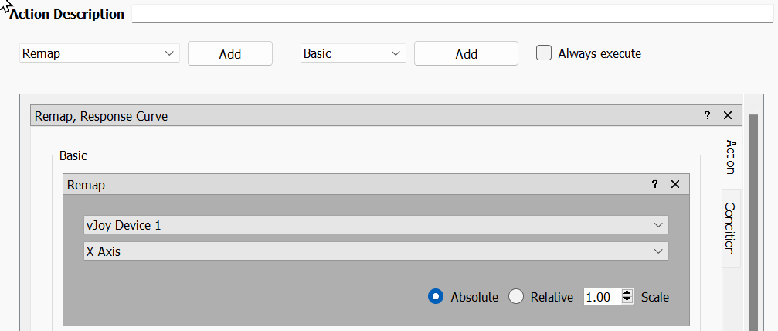
- This will add a Remap section below. Select vJoy Device 1 and X Axis in the drop downs
It should look like the above.
- Take a moment to save your profile and continue to save it periodically so you don’t lose your work. I save after each axis or button config change just to be safe.

- Do the same for Y Axis and the rest of the Axis and buttons for the right joystick. Here is a table of my mappings
Right Extreme 3D Pro Axis/Button | vJoy Axis/Button
X Axis | X Axis
Y Axis | Y Axis
Z Rotation | Z Axis
Slider | Slider
Button 1 | Button 1
Button 2 | Button 2
Button 3 | Button 3
Button 4 | Button 4
Button 5 | Button 5
Button 6 | Button 6
Button 7 | Button 7
Button 8 | Button 8
Button 9 | Button 9
Button 10 | Button 10
Button 11 | Button 11
Button 12 | Button 12

- Now select the left hand joystick tab and map those axes and buttons as in the table below. Note how I have mapped the button numbers to make it a little easier to keep track of buttons 1-12 but mapping them to buttons 21-32
- Right Extreme 3D Pro Axis/Button | - vJoy Axis/Button
- X Axis | - X Rotation
- Y Axis | - Y Rotation
- Z Rotation | - Z Rotation
- Slider | - Dial
- Button 1 | - Button 21
- Button 2 | - Button 22
- Button 3 | - Button 23
- Button 4 | - Button 24
- Button 5 | - Button 25
- Button 6 | - Button 26
- Button 7 | - Button 27
- Button 8 | - Button 28
- Button 9 | - Button 29
- Button 10 | - Button 30
- Button 11 | - Button 31
- Button 12 | - Button 32
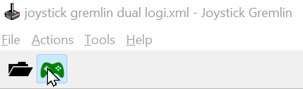
- Now press the controller button in the taskbar so that it turns green. This maps the physical devices to the virtual device. If this isn’t green you won’t have any a working virtual joystick.
- Technically you could jump right into Star Citizen and start mapping your axes and buttons right now, but don’t you want to get better control of your piloting by changing the sensitivity curves first? Of course you do!
I only set these on the X, Y, and Z axes on both joysticks. The sliders I leave as is. These are preferences, not hard and fast rules. There may also be physical differences between devices so these may have to be tweaked for make it feel right for you. But these seemed to work well for me so far
  - Select the X Axis and use the drop down on the right side of the dialog and select “Response Curve”. Then click the add button.
  - Change the “Curve Type” drop down to Cubic Bezier Spline and check both “Diagonal Symmetry” and “Force smooth curves”.
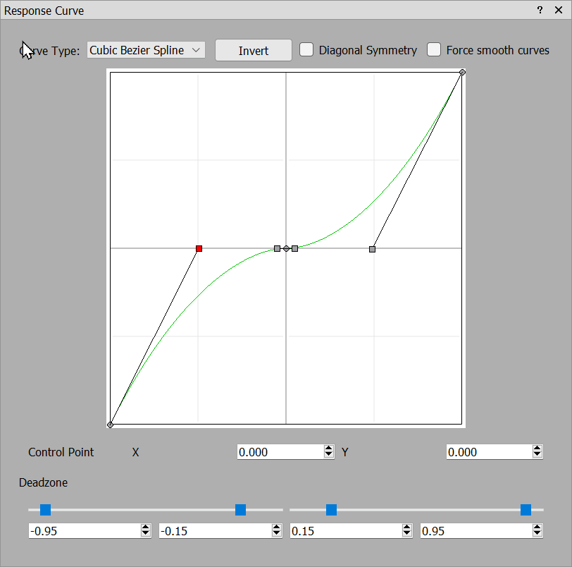
  - Anyone that has used a vector drawing program like Adobe Illustrator will know how Bezier curves work. But all I do is grab the lower left handle (the one highlighted as red) and drag it to the middle of the left half of the screen. The right half will mirror exactly what you do on the left slide.
This will give you finer control in the middle part of your axis and then accelerate as you move the axis to the outer edges.
  - I also setup deadzones to get rid of any jiggle or accidental axis movement that may occur for many joysticks. I find that the inside works best between .10-.15. You can also setup the maximum down from max to .95 but that is optional.
  - To see how these affect your joystick controls, load up the “Input Viewer” from the Tools menu. Then check “Axes – Current and “Buttons + Hats” under the “vJoy Device #1” section. To see how the sensitivity curves and deadzones affect things you can also check the “Axes – Current” for your physical joysticks as well.
If you are able to jiggle joystick access and still see unwanted jiggle on the virtual joystick output go back and adjust your deadzones.
  - Do the same thing for each X, Y, and Z axis on both joysticks.
  - You can set Response Curves on the virtual joystick. I don’t find that very logical however. Every device can be just a little different so setting these curves and deadzones for each physical device is a better way to handle these settings.
  - Now load up Star Citizen and you should have a single joystick to configure!
    - Assign the axes and buttons as you normally would. But now instead of two joysticks, you assign everything to just one virtual joystick.

Download and Use My Gremlin and Star Citizen Profile
There are two steps. First you download and configure the Gremlin profile in Joystick Gremlin. Second, you download and enable the Star Citizen layout in Star Citizen.

Joystick Gremlin Profile Config
Download the “joystick gremlin dual logi.xml” file and load it in Joystick Gremlin. Make sure to plug in your joysticks. Plugin your right joystick first, then the left joystick. But don’t worry about it too much as you can configure them with the Swap Devices tool below.
Because your joysticks have a different identifier than mine, you must now use the swap devices tool. Open the “Actions” menu and select “Swap devices”. Click the “Assigned to” box and follow the instructions to click a button or move an access for the device you want to assign. The right joystick should be assigned to the first Extreme 3D pro in the list and the left the second joystick.
Make sure to click the game controller icon on the Gremlin taskbar and that it shows as green. If it is green, it is enabled. If you ever unplug and re-plug in a joystick you will need to switch to Joystick Gremlin and re-enable the profile again. The cool thing is that you can do that without having to restart Star Citizen thanks to vJoy always having a virtual joystick ready to use.

Star Citizen vJoy Layout Config
Download and copy “vjoy-dual-logi.xml” to INSTALL_PATH\StarCitizen\LIVE\USER\Client\0\Controls\Mappings. The install path is usually something like “C:\Program Files\Roberts Space Industries”, but it may vary depending on where you personally decided to install Star Citizen.
After you have copied the file there you can load up the game. In game open the console with the backtick key (the one below the ESC key usually). Copy and paste the following command to load the joystick layout. Do NOT include the .xml from the file name.
pp_rebindkeys vjoy-dual-logi

